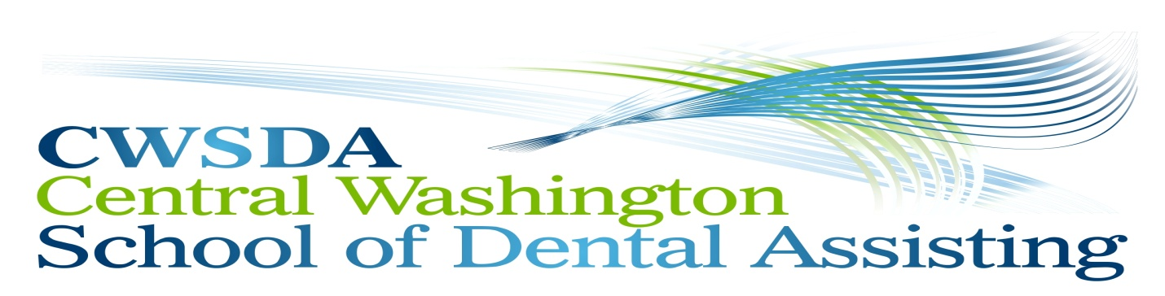
Course Catalog
“Entry Level Dental Assisting”
~ Or ~
“Entry Level Dental Reception/Billing
125 Easy Street, Wenatchee, WA 98801
Contact Gail: 509-699-1199

Spring Session 2020
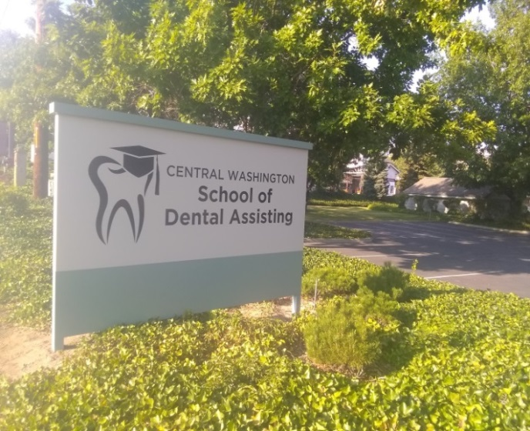
Enrollment Ends  Limited Seating | When class is full
Orientation  (8:30 am to 3:30 pm) | March 12, 2020  (subject to change)
First Class | March 21, 2020
Last Class | June 6, 2020

Course Catalog
Central Washington School of Dental Assisting, Administrative Office
125 Easy Street, Wenatchee, WA. 98801 (509) 699-1199

2020 Spring Session

Owners:Timothy L. Reynolds, DDS. and Thomas L. Reynolds, DDS.

Administrator and Qualifications:

- Gail Ford – Administrator/Instructor – Manages the school operations and administration.
Gail has 25+ years of experience in dental office reception. – Co- teaches the Entry Level Dental
Reception / Billing.

Instructors and Qualifications:

- Ronetta M. Peterson, RDA – Instructor – co-teaches the hands-on/lab experience portion of the course. Ronetta has 31+ years of experience in the dental field. As a Registered Dental Assistant, she is experienced in general dentistry, general anesthesia, sedation, X-ray techniques, OSHA practices, staff training in addition to many other assistant skills and proficiencies. – Co- teaches the Entry Level Dental Reception/Billing.

Program’s offered at Central Washington School of Dental Assisting:

Curriculum: Entry Level Dental Assisting
Clock Hours: 11 Saturdays – 8.5 hours per day – 93.5 Total Hours
8:00 a.m. to 5:00 p.m. w/ half hour lunch
Method of Instruction: ½ day lecture & ½ day laboratory
Externship: Eight (8) hours offered at Wenatchee Valley Dental Village

Overview/Objective:

Dental Assistant Training (Saturday Class)
The Central Washington School of Dental Assisting (CWSDA) Training Program prepares students for entry level employment within the Dental Industry. Students are taught general chair-side dental assisting with hands-on experience, one-on-one instruction, and coursework in terminology, sterilization procedures, preparation of the patient for treatment, X-ray examinations, chart documentation, the education of patients in proper oral health care, preparation of materials for making impressions and restorations, exposing of radiographs, and processing dental X-ray film as directed by the dentist. In addition, students will receive an introduction to orthodontics, endodontics, periodontics, general anesthesia and sedation techniques. At the end of training, the student will have completed training for and receive the AIDS/HIV certificate, CPR &Bloodborne Health Care Card and their Washington State Dental Assistant Registration.

Entry Level Dental Reception/Billing (Friday Class)
Students are taught office and customer service skills to include patient meet/greet/intake, phone etiquette/triage, dentition/terminology, team ethics, HIPAA/Law, charting/patient retention, insurance/code/billing, The History of Dentistry and the understanding of a Providers Mission Statement. They will receive class in CPR/Bloodborne Pathogens, Aids/HIV, OSHA, and the Interview process.

Instructional Materials Utilized: Dental Reception/Billing
- CDT Code Book
- Course work provided by CWSDA
- Dentrix Software

Instructional Materials Utilized: Entry Level Dental Assistant

- Text (Modern Dental Assisting)
- Student Workbook
- Instruments Flash Book
- Power Point Presentations

Tuition and Fees Entry Level Dental Assisting Class: $3,950.00

Tuition and Fees Reception and Billing Class: $2,450.00
ELDA / Rec/Bill
Registration Application Fee(Non-refundable fee to process student application and establish student record system) | $100.00/ $100.00
Tuition Down Payment(at any time to reserve place in class, deducted from total course cost) | $1,500.00/ $1,500.00
Tuition Final Payment ( received two full weeks prior to orientation) | $2,350.00/ $ 850.00
Books(Included in total course cost) | $0.00
Supplies and Materials(Included in total course cost) | $0.00
Other Fees and Charges | $0.00
TOTAL COST FOR THE COURSE | $3,950.00/ $2,450.00

Students will need to meet all financial responsibilities prior to Orientation date. Tuition fees subject to change.

School Calendar and Class Schedules

The following holidays will be observed and classes will not be held.
- Holiday : May 23, 2020 Memorial Weekend
Holidays are not part of the contracted time schedule.

Enrollment periods are up when class is full.

Orientation Dates: Thursday; March 12, 2020~8:30 a.m. to 3:30 p.m. (Subject to change)

Program Start Dates: March 21, 2020 through June 6, 2020

**All dates are subject to change. Please contact administration office for any changes**

The total hours of each quarter are 93.5 hours. Business hours are from 7am to 6pm Monday to Thursday and 7am to 5 pm Friday. Classes are scheduled on the designated Saturdays from 8am to 5pm with a 30 minute break for lunch. Same class hours will apply to any Friday class if available.

Facilities

The bright, open reception area welcomes students to an atmosphere very similar to a functioning dental office. The facility contains a classroom, seven teaching dental workstations, instrument and preparation areas, in addition the use of the kitchen, restrooms, lockers, etc. The ample parking area has over 30 spaces located in a well-lit, easy access private lot surrounding the building and monitored by security cameras. It provides disability parking and access as per state and local codes. The facility is within easy walking distance of numerous eating establishments. The maximum class size is 16 and the student/teacher ratio is 8 to 2 on lecture days and the potential of 2.67 to 6 on final assessment days with the assistance of Registered Dental Assistants from Wenatchee Valley Dental Village.

Entrance Requirements

Students must possess a High School Diploma/Transcripts or General Education Development (GED) Diploma/Transcripts. Students must request a copy of their official transcripts from their last graduating High School or GED. These transcripts must be received by Central Washington School of Dental Assisting no later than the orientation date. Also, students must complete the registration packet and short essay questions to be considered for the program. If you are unable to obtain transcripts you may request to take an “Ability to Benefit” test given at the school.

Attendance Requirements

Central Washington School of Dental Assisting records the daily attendance of each student. Records are available for student review. Attendance is required and mandatory for every class. In the event of a missed class, the school administrator with determine whether the absence will be excused or unexcused. All absence excused or unexcused require 24 hour notice.

Excused Absence – If more than 1 class needs to be missed the case will be reviewed by the school director/administrator with the likelihood of being dropped from the program. See make-up work policy.

Unexcused Absence – Absences will not be tolerated. See conditions for dismissal.

Make-up Work
Lessons and/or assignments missed due to excused absences must be made-up within five business days of returning to school. Students should meet with their instructors to get missed assignments.

Tardiness
Developing good work ethics is an important part of the training at Central Washington School of Dental Assisting. Central Washington School of Dental Assisting has a point system in place to grade students on attendance and tardiness. Students arriving late for class are interrupting the instructor and other students during important class time. The following recording system will be used for tardiness.

- 1 to 15 minutes late will be counted as 15 minutes late.
- 16 to 30 minutes late will be counted as 30 minutes late.
- 31 to 60 minutes late will be counted as 1 hour late.

The make-up work policy will then be instituted in the event of tardiness. Points will be deducted from a student’s attendance grade based on the chart above.

Code of Conduct

The following conduct is unacceptable and will not be tolerated:

- All forms of bias including race, ethnicity, gender, disability, national origin, and creed as demonstrated through verbal and/or written communication and/or physical acts.
- Sexual harassment including creating a hostile environment and coercing an individual to perform sexual favors in return for something.
- All types of proved dishonesty, including cheating, plagiarism, knowingly furnishing false information to the institution, forgery, and alteration or use of institution documents with intent to defraud.
- Intentional disruption or obstruction of teaching, administration, disciplinary proceedings, public meetings and programs, or other school activities.
- Theft or damage to the school premises or damage to the property of a member of the school community on the school premises.
- Violation of the law on school premises. This includes, but is not limited to, the use of alcoholic beverages or controlled dangerous substances.

Conditions for Dismissal

Students may be dismissed from the school for the following reasons:

- Not adhering to the school’s rules, regulations, policies, and code of conduct.
- Missing one day of unexcused instruction time.
- Not meeting financial responsibilities to the school.

The school director will notify the student in writing should it become necessary to dismiss the student. The dismissal letter will contain the date and the reason for dismissal. Tuition will be refunded according to the school’s refund policy.

Re-entry Policy

Students dismissed from the school who request re-entry must put the request in writing to the school director/administrator. In cases where the student was dismissed for excessive absences (more than 1 class) or financial concerns, it may be possible to re-enter the next quarter. In cases where the student was dismissed due to unacceptable conduct, the student may have to meet with the director/administrator before re-entering the school. The decision of the director/administrator is final and the student will receive a letter within five business days stating the decision.

Discrimination Policy

Central Washington School of Dental Assisting does not discriminate against students or potential students on the basis of race, creed, color, national origin, sex, veteran or military status, sexual orientation, or the presence of any sensory, mental, or physical disability or the use of a trained guide dog or service animal by a person with a disability.

At the time of registration it will be the student’s responsibility to inform and/or request in writing accommodations needed for his or her disability.

Student Complaint/Appeal Process

Students who have a complaint or who would like to appeal a dismissal must request in writing an appointment for an interview with the school director. The written request should include the following information.

- Student’s full name and current address
- A statement of the concern including dates, times, instructors, and if applicable, other students involved.
- Date of complaint letter and signature of the student
- Three dates in which the student would be available for a meeting the school director. These dates should be within 10 business days of the complaint.

The school director will notify the student in writing of the appointment date in which the concerns or appeal will be addressed. Every effort will be made to bring an amicable closure to the concern. Should it be necessary, a panel of instructors will hear the concerns and will be asked to assist in bringing a resolution to concerns and/or appeals? The student will be notified in writing within five business days of the outcome of the meetings. Should the contract be canceled by either the student or the school the last date of attendance will be used as the date to calculate any refund in accordance with the school’s refund policy. Nothing in this policy prevents the student from contacting the Workforce Board (the state licensing agency) at 360-709-4605 at any time with a concern or a complaint.

Grading System

The students will be formatively assessed by answering questions during discussion, completing student workbooks, quizzes, and one formal exam (Final Exam). Students will also be assessed by demonstrating their knowledge of the material learned within the allotted hands-on time and attendance. Grades will be entered into the school’s administration software. Students will be able to obtain their grades at any time by asking the instructor. Students will also be given progress reports throughout each session. For further information, see the class syllabus given to students at the orientation.

Incomplete Grades

Incomplete grades are given when a student is unable to complete a course because of illness or other serious problems. An incomplete grade may also be given when students do not turn in work or do not take tests. If a student does not make arrangement to take missed tests, a failure grade will be given. A student who misses a final test must contact the instructor within twenty-four hours of the test to arrange for a make-up examination.

Probation For Below Average Grades

Students who fail to maintain the minimum grade point average of 80 percent required for certification will need to enter a probation period. The student will be scheduled for in-school counseling. Students unable to increase their grade point averages may be dismissed from the program. Refunds will be given in accordance with the school’s refund policy.

Student Evaluation Techniques

A test may be administered after each lesson to determine the amount of learning that has taken place. Test scores that are below 80 percent are an indication that the necessary skills for entry into employment were not acquired. Students should make arrangements with the instructor and administrator to address the situation. Other methods of evaluation may include oral quizzes, skill development tests, hands-on skill evaluation, and individual and group projects.

Withdrawing from School

Students must prepare a written notification and withdrawal form and submit it to the school director. This document must contain the student’s name, address, date, and reason for withdraw. All financial obligations on the part of the school and the student will be calculated using the last recorded date of attendance and the refund policy.

Student Records

Student records will be maintained by the school for 50 years or until the school closes. If the school closes, records may be forwarded to the Workforce Training and Education Coordinating Board. These records should be maintained indefinitely by the student. Students may request copies by filling out the request transcripts form. Student records are available for review by the student at any time.

Cancellation and Refund Policy

Should the student’s enrollment be terminated or should the student withdraw for any reason, all refunds will be made according to the following refund schedule:

- The school must refund all money paid if the applicant is not accepted. This includes instances where a starting class is canceled by the school.

- The school must refund all money paid if the applicant cancels within five business days (excluding Sundays and holidays) after the day the contract is signed or an initial payment is made, as long as the applicant has not begun training.

- The school may retain an established registration fee equal to 10 percent of the total tuition cost, or $100, whichever is less, if the applicant cancels after the fifth business day after signing the contract or making an initial payment. A “registration application fee” is any fee charged by a school to process student applications and establish a student record system. If the student cancels prior to the class orientation the registration fee will be valid for the following two quarters.

- If training is terminated after the student enters classes, the school may retain the registration fee established under #3 above, plus a percentage of the total tuition as described in the following table:

If the student completes this amount of training: | The school may keep this percentage of the tuition cost:
One week or up to 10% whichever is less | 10%
More than one week or 10% whichever is less but less than 25% | 25%
25% but less than 50% | 50%
More than 50% | 100%

- When calculating refunds, the official date of a student’s termination is the last day of recorded attendance:
  - When the school receives notice of the student’s intention to discontinue the training program;
  - When the student is terminated for a violation of a published school policy which provides for termination; or,
  - When student, without notice, fails to attend classes for 30 calendar days.

- All refunds must be paid within 30 calendar days of the student’s official termination date.

Credit Policies

Financial payments can be made through Cash, Check, Visa/Master Card, Discover and American Express. Students or parents can call Gail at 509-699-1199.

Placement Assistance

Central Washington School of Dental Assisting will provide letters of recommendation written by one or more instructors if requested by the student. The administration will post any local jobs that are supplied by area Dentists or Practices. This will be posted in house.

Licensure

This school is licensed under Chapter 28C.10 RCW. Inquiries or complaints regarding this private vocational school may be made to:

“Selected programs of study at Central Washington School of Dental Assisting are approved by the Workforce Training and Education Coordinating Board’s State Approving Agency (WTECB/SSA) for enrollment of those eligible to receive benefits under Title 38 and Title 10, USC.”

Religious Accommodation

The Central Washington School of Dental Assisting will make good faith efforts to provide reasonable religious accommodations to students who have sincerely held religious practices or beliefs that conflict with a scheduled course/program requirement. Students requesting a religious accommodation should make the request in writing, directly to their instructor with as much advance notice as possible. Being absent from class or other educational responsibilities does not excuse students from keeping up with any information shared or expectations set during the missed class. Students are responsible for obtaining materials and information provided during any class missed. The student shall work with the instructor to determine a schedule for making up missed work.

“Catalog certified as true and correct for content and policy”

Workforce Training and Education Coordinating Board
128 – 10th Avenue Southwest
Olympia, Washington 98504
(360) 709-4605
workforce@wtb.wa.gov

Central Washington School of Dental Assisting

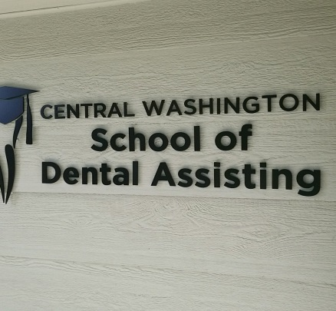
Administrative Office (by appointment) CWSDA Training Facility
125 Easy Street 125 Easy Street
Wenatchee, WA 98801 Wenatchee, WA. 98801
Telephone: (509) 699 - 1199 509-699-1199

E-Mail: info@cwsda.com
FB: CWSDA
Web: CWSDA.com

Central Washington School of Dental Assisting Enrollment Agreement
125 Easy Street, Wenatchee, WA 98801 ∙ (509) 699-1199

_____Entry Level Dental Assisting Or _____Entry Level Dental Reception & Billing

This Enrollment Agreement is between the above named school and:

Student Information (Email Address: ___________________________________________)

Legal Name
 |  |  | Last Name (Family) |  |  |  | First Name |  |  |  | Middle |  |  | Suffix (Jr., Sr., etc.)
Date of Birth |  |  |  |  | SSN # |  |  |  |  | Male □ Female □
 |  |  | (mm/dd/yyyy) |  | (xxx-xx-xxxx)
Permanent Address
 |  |  |  | Street Address |  |  |  |  |  |  |  |  | Apt. #
 |  |  |  | City/Town |  |  |  |  | State |  |  | Zip Code
Phone | ( ) |  |  |  |  |  |  | Alternate Phone | ( )
 | Begin with area code |  |  |  |  |  |  |  | Begin with area code
Parent/Guardian Information (If under 18 yrs of age – or – responsible for payment)

Legal Name
 |  |  | Last Name (Family) |  |  |  | First Name |  |  |  | Middle |  |  | Suffix (Jr., Sr., etc.)
Date of Birth |  |  |  |  | SSN # |  |  |  |  | Male □ Female □
 |  |  | (mm/dd/yyyy) |  | (xxx-xx-xxxx)
Permanent Address
 |  |  |  | Street Address |  |  |  |  |  |  |  |  | Apt. #
 |  |  |  | City/Town |  |  |  |  | State |  |  | Zip Code
Phone | ( ) |  |  |  |  |  |  | Alternate Phone | ( )
 | Begin with area code |  |  |  |  |  |  |  | Begin with area code
The school agrees to provide the following training:

Program Title: Entry Level Reception /Billing and/or Entry Level Dental Assisting

Start date: __________________________________ Completion date: _________________________________

Program consists of 11 weeks x 8.5 hours per week = 93.5 total hours.

All Inclusive Tuition Fee

Entry Level Dental Assisting: $3,950.00 ~ Spring Session 2020

Dental Reception and Billing: $2,450.00 ~ Spring Session 2020

Registration Application fee is due when application is submitted.

Tuition Down Payment is due when application has been accepted. A place will be held in the class when payment is received. Student will be notified by the Administrator when your application has been approved and the date(s) that the fees are due.

Tuition Final Payment is due on or before the orientation date.
Payments are accepted in the form of Cash, Check, Visa, Master Card, Discover/American Express and Money Order.

Agreement is binding:
This agreement will be binding only when it has been fully completed, signed, and dated by the student or student’s parent or guardian if he/she is a minor and an authorized representative of the school prior to the time instruction begins.

Changes in the Agreement:
Any changes in the agreement will not be binding on either the student or the school unless such changes are acknowledged in writing by an authorized representative of the school and by the student or the student’s parent or guardian if he/she is a minor.

Effective Date of Acceptance:
I certify that I have read and understand the cancellation and refund policy and the complaint procedure; I have received a copy of the school catalog; and I am entitled to an exact copy of this Enrollment Agreement, school catalog, and any other papers I sign.

Cancellation of Classes:
The school reserves the right to cancel a starting class if the number of students enrolling is insufficient. Such a cancellation will be considered a rejection by the school and will entitle the student to a full refund of all money paid.

Cancellation and Refund Policy for Training Programs:
- The school must refund all money paid if the applicant is not accepted. This includes instances where a starting class is canceled by the school.
- The school must refund all money paid if the applicant cancels within five business days (excluding Sundays and holidays) after the day the contract is signed or an initial payment is made, as long as the applicant has not begun training.
- The school may retain an established registration fee equal to 10 percent of the total tuition cost, or $100, whichever is less, if the applicant cancels after the fifth business day after signing the contract or making an initial payment. A “registration application fee” is any fee charged by a school to process student applications and establish a student record system. If the student cancels prior to the class orientation the registration fee will be valid for the following two quarters.
- If training is terminated after the student enters classes, the school may retain the registration fee established under #3 above, plus a percentage of the total tuition as described in the following table:

If the student completes this amount of training: | The school may keep this percentage of the tuition cost:
One week or up to 10%, whichever is less | 10%
More than one week or 10% whichever is less but less than 25% | 25%
25% through 50% | 50%
More than 50% | 100%
- When calculating refunds, the official date of a student’s termination is the last day of recorded attendance:
  - When the school receives notice of the student’s intention to discontinue the training program;
  - When the student is terminated for a violation of a published school policy which provides for termination; or,
  - When student, without notice, fails to attend classes for 30 calendar days.

- All refunds must be paid within 30 calendar days of the student’s official termination date.

Notice to Buyer:
Do not sign this agreement before you read it or if it contains any blank spaces. This is a legal document. All pages of this agreement are binding. Read all pages before signing. You are entitled to an exact copy of the agreement, school catalog, and any other papers you may sign and are required to sign a statement acknowledging receipt of those.

Cancellation of Contract:
If you have not started training, you may cancel this contract by submitting written notice of such cancellation to the school at its address shown on the contract, which notice shall be submitted not later than midnight of the fifth business day (excluding Sundays and holidays) following your signing this contract or the written notice may be personally or otherwise delivered to the school within that time. In event of dispute over timely notice, the burden to prove service rests on the sender.

Unfair Business Practices:
It is an unfair business practice for the school to sell, discount, or otherwise transfer this contract or promissory note without the signed written consent of the student or his/her parent or guardian if he/she is a minor and a written statement notifying all parties that the cancellation and refund policy continues to apply.

Signature:
You are entitled to an exact copy of the agreement, school catalog, and any other papers you may sign and are required to sign a statement acknowledging receipt of those. By signing below, you are acknowledging receipt of an exact copy of the agreement, school catalog and any other CWSDA paperwork you may have signed.

Signature of Student:
Printed Name:
Date:
Signature of Parent/Guardian :
(if student is under 18 years)
Printed Name:
Date:

As the authorized representative of the school, I hereby agree to the conditions set forth herein:

Signature Authorized
School Representative:
Printed Authorized
School Representative:
Date:

Washington law requires the following information to be supplied to each student enrolling in a private vocational school licensed under RCW 28C.10. One copy of this notice bearing original signatures must be attached by the school as an addendum to that individual’s enrollment agreement and a copy must be provided to the enrollee by the school.

AKNOWLEDGMENT BY ENROLLEE

1. I understand and accept that any contract for training I enter into with the above named school contains legally binding obligations and responsibilities.

2. I understand and accept that repayment obligations will be placed upon me by any loans or other financing arrangements I enter into as a means to pay for my training.

3. I understand that any enrollment contract I enter into will not be binding or take effect for at least five days, excluding Sundays and holidays, following the last date such a contract is signed by the school and myself, provided that I have not entered classes sooner.

Student Name (Please Print):
Signed:
Date:

(If Student is under 18 years of age)
Parent or Guardian Name (Please Print):
Signed:
Date:

ACKNOWLEDGMENT BY SCHOOL

Prior to being enrolled in this school, the applicant whose name and signature appears above has been made aware of the legal obligations he/she takes on by entering into a contract for training. Those discussions included cautions by the school about acquiring an excessive debt burden that might become difficult to repay given employment opportunities and average starting salaries in his/her chosen occupation.

Signed:
Title:
Date:

This school is licensed under Chapter 28C.10 RCW. Inquiries or complaints regarding this private vocational school may be made to the:

Workforce Board, 128 – 10th Ave. SW, Box 43105, Olympia, Washington 98504
Web: wtb.wa.gov
Phone: 360-753-5662

Central Washington School of Dental Assisting
125 Easy Street
Wenatchee, WA 98801
509.699.1199

How To file a Complaint

Washington law requires private vocational schools to inform students how to file a complaint. By signing this form you acknowledge this process has been explained to you. Below are the next steps the school must take in discussing this policy with you, along with information about the complaint process.

Discussion about complaint policy required

First, a school representative must discuss the school's complaint policy with you. Following this discussion, you will be provided with this attachment to sign. After you sign this form, the school will give you a copy for your person records. The School will also keep a copy on file.

Acknowledgment of complaint process by student

1. The school has described the grievance and/or complaint policy to me.
2. I understand that the policy can also be found in the school catalog.
3. I know I should first try to resolve a complaint or concern with my instructor or school administrator.
4. I understand nothing prevents me from contacting the Workforce Board at 360-709-4600 at any time with a concern or complaint, and complaint forms are: http://wtb.wa.gove/PCSComplaints.asp.
5. I understand that I have one year to file a complaint from my last date of attendance.
6. I further understand that in the event of a school closure, I have 60 days to file a complaint.
7. I also understand that complaints are public records.
8. Finally, I acknowledge that details about the complaint process, my rights, and any restrictions on the time I have to file a complaint can be found at http://wtb.wa.gov/PCSCompaints.asp.

Name:________________________________________ Signature:_______________________________

Date:______________, 20____

Acknowledgment by school

Prior to being enrolled in this school, the applicant, whose name and signature appear above, has been made aware of the school's complaint policy.

Name:_____________________________ Signature:__________________________________________

Title:________________________________________________________

Date:________, 20____

By Mail - Payment Remittance Advices
Please detach and include one remittance advice with each payment for proper credit
===================================================================================
Payment due dates for the Entry Level Dental Assisting Course
(Please check one)
____ $100 Non-Refundable Registration Application Fee (Due when application is submitted. Separate from Tuition)

____ $1,500 Tuition Down Payment (Reserve place in class)
____ $2,350 Tuition Final Fee (Due no less than two weeks prior to Orientation)
____ $3,950 Total fees Paid-in full (choose this option if you prefer to pay in one payment.)

____ Visa ____ Mastercard ____ Check ____ Money Order ____ Discover _____American Express

Student Name:_______________________________________________________________________________________
Credit Card #:_____________________________________3-DigitVerificaiton_____ Exp. Date: _______
Name (on card): ___________________________________________________Date of Birth: _______________________
Address: __________________________________________________City:______________________ Zip: ____________
Signature: _________________________________________________

===========================================================================
Please detach and include one remittance advice with each payment for proper credit
===================================================================================
Payment due dates for the Entry Level Dental Reception/Billing Course:
(Please check one)
____ $ 100 Non-Refundable Registration Application Fee (Due when application is submitted. Separate from Tuition)

____ $1,500 Tuition Down Payment (Reserve place in class,)
____ $ 850 Tuition Final Fee (Due no less than two weeks prior to Orientation)
____ $2,450 Total fees Paid-in full (Choose this option if you prefer to pay in one payment.)

____ Visa ____ Mastercard ____ Check ____ Money Order____ Discover ______American Express

Student Name:_______________________________________________________________________________________
Credit Card #:_____________________________________3-DigitVerificaiton_____ Exp. Date: _______
Name (on card): ___________________________________________________Date of Birth: _______________________
Address: __________________________________________________City:______________________ Zip:____________
Signature: _________________________________________________
===========================================================================

Central Washington School of Dental AssistingRegistration Application
125 Easy Street, Wenatchee, WA. 98801 ∙ (509) 699-1199

Entry Level Dental Assisting: ____Winter 2020, _____Spring 2020, _____Summer 2020, ______Fall 2020

Entry Level Dental Reception: ____Winter 2020, _____Spring 2020, _____Summer 2020, ______Fall 2020

Personal Information

Legal Name
 |  |  | Last Name (Family) |  |  |  | First Name |  |  |  |  | Middle |  |  |  |  | Suffix (Jr., Sr., etc.)
Date of Birth |  |  |  |  | SSN # |  |  |  |  |  | Male □ Female□
 |  |  | (mm/dd/yyyy) |  | (xxx-xx-xxxx)
Permanent Address
 |  |  |  | Street Address |  |  |  |  |  |  |  |  |  |  |  | Apt. #
 |  |  |  | City/Town |  |  |  |  | State |  |  |  |  | Zip Code
Mailing Address
 |  |  |  | Street Address |  |  |  |  |  |  |  |  |  |  | Apt. #
 |  |  |  | City/Town |  |  |  |  |  | State |  |  | Zip Code
Phone | ( ) |  |  |  |  |  |  | Alternate Phone | ( )
 | Begin with area code |  |  |  |  |  |  |  | Begin with area code
Parent/GuardianInformation(If student is under age 18) (Or financially responsible)

Legal Name
 |  |  | Last Name (Family) |  |  |  | First Name |  |  |  |  | Middle |  |  |  |  | Suffix (Jr., Sr., etc.)
Date of Birth |  |  |  |  | SSN # |  |  |  |  |  | Male □ Female□
 |  |  | (mm/dd/yyyy) |  | (xxx-xx-xxxx)
Permanent Address
 |  |  |  | Street Address |  |  |  |  |  |  |  |  |  |  |  | Apt. #
 |  |  |  | City/Town |  |  |  |  | State |  |  |  |  | Zip Code
Mailing Address
 |  |  |  | Street Address |  |  |  |  |  |  |  |  |  |  | Apt. #
 |  |  |  | City/Town |  |  |  |  |  | State |  |  | Zip Code
Phone | ( ) |  |  |  |  |  |  | Alternate Phone | ( )
 | Begin with area code |  |  |  |  |  |  |  | Begin with area code
Emergency Contact Information
Legal Name
 |  |  | Last Name (Family) |  | First Name |  |  |  | Middle | Suffix (Jr., Sr., etc.)
Phone | ( ) |  |  |  |  | Alternate Phone |  | ( )
 | Begin with area code |  |  |  |  |  |  | Begin with area code
Relationship to Student

Academic Information
School Level | Name and Location of School | No. of Years Attended | Did you Graduate? | Subjects Studied
High School
College
Trade, Business or Correspondence School

In Addition to the above provided information, please submit official transcripts from your graduating High School or GED.

**Official transcripts must be received from the school(s) prior to the orientation date. **

Academicor Community Distinctions
Please list any academic or educational awards and honors you received in high school or within the community (e.g. National Merit, National Honor Society).

Extracurricular and Volunteer Information
Please list any significant extracurricular or community activities and hobbies in which you have participated. Include specific accomplishments such as musical accolades, athletic distinctions, etc.

Writing
Please briefly answer each question below.

Why have you chosen the career path of a Dental Assistant?

Please explain or give an example of your customer service experience.

Discipline Information

Have you ever been placed on probation, suspended, removed, dismissed or expelled from any school or academic program since 9th grade? | Yes □ | No □
Other than traffic offenses, have you ever been convicted of any misdemeanor, felony, or other crime? | Yes □ | No □

If you answered yes to either question, please provide an explanation and the approximate dates of each incident. Please attach your response to the end of the application.

Signature

Application Fee Payment

- $100.00 Non-Refundable Registration Application Fee must be included to process this application.Please submit with payment remittance that is provided on the Enrollment Agreement.

I certify that all information submitted in the admission process – including the application, writing, any supplements, and any other supporting materials – is my own work, factually true, and honestly presented, and that these documents will become the property of the institutions to which I am applying and will not be returned to me. I understand that I may be subject to a range of possible disciplinary actions, including admission revocation, expulsion, or revocation of course credit, grades, and certification, should the information I have certified be false.

Refunds and Cancellations
We are a licensed private vocational school for Dental Assistants in Washington State. Our program is licensed by the Workforce Board and therefore we abide by all refund and termination policies regulated by the State.

Work Force Board 128 10th Avenue SW Olympia, WA 98504 (360) 586-8682. http:/:www.wtb.wa.gov

Signature of Student:
Printed Name:
Date:
Signature of Parent/Guardian :
(if student is under 18 years)
Printed Name:
Date:

How did you hear about this program? _____________________________________________________

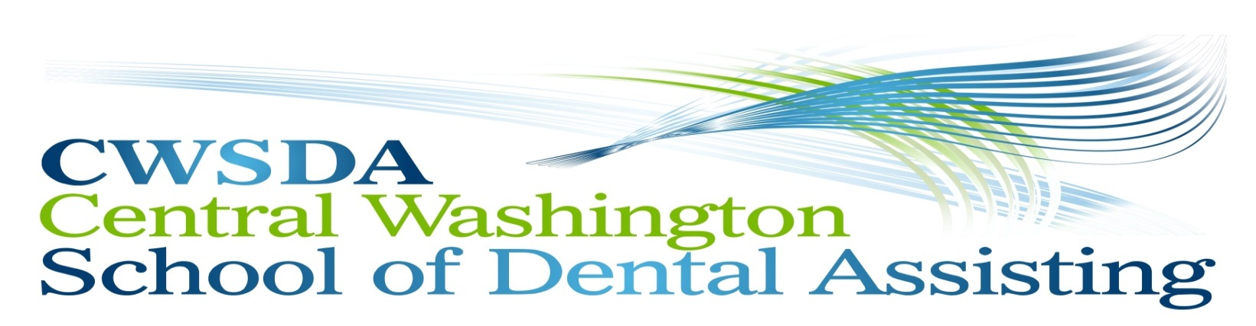
Entry Level Dental Assisting or Entry Level Dental Reception

WELCOME!!! DA-Spring Class: March 21, 2020 through June 6, 2020 (Saturday)
R/B-Spring Class: March 21, 2020 through June 6, 2020 (Friday)
We are pleased that you have requested the necessary paperwork to apply for our Vocational training program. Things to know and items to provide upon registration.

In this packet you will find:

Course Catalog: | Full scope of information to answer any questions you may have.
Registration Application: | To be completed and returned with a $100.00 non-refundable registration fee.  To Reserve your seat in the class at any time with an initial payment of$1,500.00 (portion of tuition) Balance of final tuition payment is due, in full, two weeks prior to the orientation date.
Enrollment Agreement: | To be completed and returned with Registration Application

Additional Information:

Transcript Request: | - Please contact your graduating High School / GED for official transcripts (School must receive Official Transcript prior to orientation)
Orientation: | - Orientation will be on Thursday; March 12, 2020  - 8:30 am to 3:30pm. (subject to change)  - Aids/HIV training will be completed, books and supplies will be disbursed and scrub size identified.
Lecture & Lab Time: | - A syllabus will be provided at orientation as to lab and lecture topics and weekly assignments identified.

Items listed above must be completed and returned prior to orientation. If items are not completed and returned as requested contact Gail at 509-699-1199 for guidance or your application may not be considered for the current session.

Please feel free to call me with any questions, no question is too small!

Thank you,
Gail Ford, Administrator
509-699-1199

